Name: Shay Walker

Box #613

Professor Sabal

Cairn University School of Business

CIS122 Essentials of Networking

Project #6

Project objective:

Set up an IIS web server and learn to add and maintain new ports.

Equipment used:

|  |  |  |  |  |
| --- | --- | --- | --- | --- |
| Equipment Description | Vendor | Vendor Item # | Retail price | Actual price (if known) |
| Lenovo ThinkCentre M800z - all-in-one - Core i3 6100 3.7 GHz - 4 GB - 500 GB - LED 21.5" | Zones | 003446752 | $904.99 | N/A |
| Dell PowerEdge R230 - rack-mountable - Xeon E3-1220V6 3 GHz - 8 GB - 1 TB | Zones | 005319820 | $937.99 | N/A |
| NETGEAR RangeMax Open Source Wireless-N Gigabit Router WNR3500L - wire | Zones | 02948590 | $53.99 | N/A |
| Windows Server 2012 Standard License | Direct Deals | 02948590 | $399.99 | N/A |

Detailed list of software and operating platforms used, including version numbers and licensing requirements: Windows Server 2012 Standard License (Windows operating system)

Network diagram:

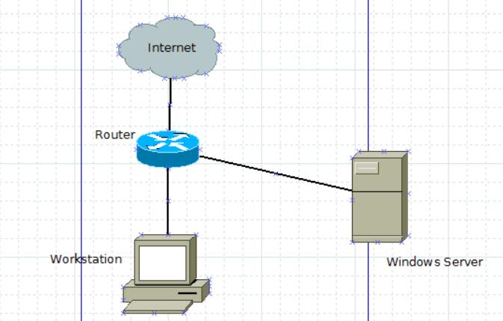

Configurations:

1. Access Server Manager through the Control Panel
2. Go to the System and Security window to the Administrative tools
3. Locate the IIS Manager:

Open tab: CSWIGRV (main directory)

Locate Sites

Add new website

1. The Add Website Window open

Type the site name that you desire

Designate the physical path (directory of the website)

Type desired port to be used (Ex. port 8008)

Designate the Host name (Ex. localhost)

1. Click Add
2. Create Index

Create a new text document

Edit

Save it as an html file, named index.hml file

Set up what you desire the web page to display when viewed

1. Edit permissions to include the desired users (most often give everyone read-only permission)